How to run a successful Facebook webinar
There are several factors and steps that can help you create a successful webinar. In this document we will outline the webinar campaign and all the steps needed to create the success you want.

Overview
Webinars have become a staple marketing tool for many advisors and businesses across America. There are several ways to create a successful webinar. In this document, we will outline one way to create a successful webinar similar to those we have done within our program.
Here is a basic overview of our campaign and the results we see:
- Average cost per lead: $115
- Attendance rate: 54%
- Average cost per Attendee: $230
- Conversion rate (Conversion/leads): 27%
- Average cost per conversion $460
A conversion is someone who either set an EW meeting or 101 Class. We used “lead” as the base conversion rate denominator. This is because we found that 33% of our conversions came from people who signed up but did not attend.
The biggest key to a successful campaign is the follow up. It is important to Call the attendees and no-shows as soon as possible after the meeting (the following day).
The webinar itself is a modified version of the Education workshop, with several other slides that help build the case that these leads need to take the next step – learn more.
The average cost for one webinar will be approximately $1500. All those dollars go into the Facebook advertising.

Goals/Objectives
It is important to understand that we are not trying to take these leads from this webinar straight to the 1st appointment. The goal is to get them more education, plus they need to understand some principles and make some commitments that are not included in this webinar.
Our goal is to get them to a 15 min “Next Steps” meeting. The goal of this meeting is to see if the EW meeting or Educational Workshop is the next logical step for this person.

Process
We have broken up the process in four segments.
- Planning & Preparation
- Promotion
- Presentation
- Follow up

Planning & Preparation
Here are all the major components of the campaign:
- The presentation slides.
  - You can access a copy of the slides here: https://drive.google.com/file/d/1kSCx9hlrgnaN4Yx9HD26GLsuI1Uem8bV/view?usp=sharing
  - You will need to brand these to match your business.
- The Landing page
  - You can view a copy of our landing page here: https://fta-ria.com/7-mistakes-to-avoid-webinar/
  - You will need to work with Marketing to be able to build and integrate it with your Webinar software and Infusion/Keap
- The webinar software (Zoom/GoToWebinar)
  - You will need the webinar version of either Zoom or GoToWebinar. You cannot do this with the free version, or even the paid version, but standard meeting versions.
- CRM
  - This is the key to making this work. This performs all the confirmation functions for you, that ensures you have the highest attendee rate as possible.
  - You will need either Infusionsoft (now called Keap Max classic) or Keap Pro. Talk to Ben if you need to get this.
- Facebook ads
  - Here is a document of what the Facebook ads will contain (content and thumbnail): https://drive.google.com/file/d/1TtubL_0xOQAFMyqvuRqyPpjBJ504sOTA/view?usp=sharing
  - We will use this as our template to build the ads.
  - Here is a sample of one of those ads as it appears on Facebook:
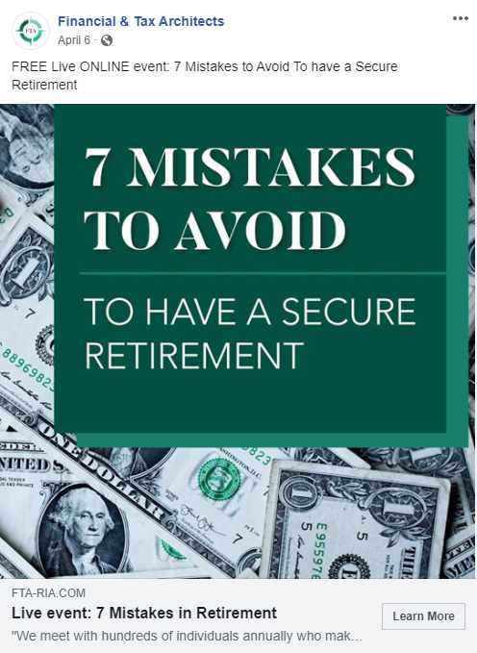

Steps to launch your campaign.
- Determine date of your event.
  - Ideally, we need about four weeks lead time for the first campaign.
  - Two to 3 weeks for every campaign thereafter.
- Meet with Ben.
  - He will work with the Digital agency that produces the ads.
  - And will work with you and our Contractor to do the next three steps.
- Add needed tracking to your site/landing page
- Build landing page and connect it with your CRM and webinar software
- Add confirmation campaign and follow up campaign to your CRM
- Prepare the slides in your brand.
- Practice. Practice. Practice.
- Record your presentation – We will need to schedule this with Matt. It needs to be at least two days ahead of your event.

Promotion
Our main focus for this campaign is to generate “net new” leads through Facebook. So the primary driver will be Facebook ads.
These ads will start approximately six days prior to your event.
Our secondary focus – if you choose to add this portion, is to email your “old prospects.” These are people who are not active in your pipeline. The email will go out the same day you start promoting the event on Facebook.

Presentation
As discussed in the steps above, you can choose to record your presentation if you wish. You will just need play it on the night of your event. The recording will look and feel like it is live. We don’t take questions at the end, so that part becomes a non-issue. You will need someone to monitor the chat for any questions that might arise during the webinar. You can watch Mark Kukielski’s presentation here: https://vimeo.com/537327203/62870ba2ed

Follow up
THIS IS THE SINGLE MOST IMPORTANT PART OF THIS CAMPAIGN.
We have found very few of the attendees contact us after attending the event to sign up for the next steps meeting. However, they are very receptive when we call them.
You must call them the day following the event, both the attendees and the non-respondents.
The system will send them an email the following morning, once you have uploaded the “attendee list.” It will send an email to all the no-shows, with the opportunity to watch the presentation.

Resources

Sample promo email for Old Prospects
Hello [Name],

Live Online Event

7 Mistakes to Avoid for a Secure Retirement
We meet with hundreds of individuals annually who make one or more of these crucial mistakes. Learn to avoid these common mistakes, and how to turn them into potential opportunities with our FREE Live ONLINE event.
Registration is FREE for this ONLINE event.
Join us
When: Wednesday, April 14 at 6:30pm
Location: computer, tablet or phone
Presented by noted Retirement Educator Mark Kukielski.
In this presentation you will learn:
- How to have guaranteed income in retirement
- How market risk affects your retirement nest egg
- How to reduce or potentially eliminate taxes in retirement
- How taking Social Security at the wrong time could cost you over hundreds of thousands of dollars
- A new way to plan for long-term care

Learn More

Look forward to seeing you there.

Attended Webinar email
Hello ~Contact.FirstName~,

Thank you for attending our 7 Mistakes to Avoid for a Secure Retirement webinar!
We hope you enjoyed it. We will be reaching out to each of you over the next week to answer any questions you might have. In the meantime, if you have questions please don't hesitate to reach out to us.
If you would like to attend one of our Retirement 101 classes, you can schedule your class two ways:
Visit: https://fta-ria.com/retirement-101-class/
Call: (314) 470-8830
All who attend one of our classes receive a free, no-obligation, in-depth retirement plan.
You can also watch a recorded version of the webinar here at your convenience.

Webinar No-Show
Hello ~Contact.FirstName~,

Sorry we missed you!
We had a great webinar! We understand that life can be a bit busy. We recorded the webinar and are making it available for you to watch. Simply click on the link below to view it.
Thank you for your time and hope you will enjoy the recorded webinar. Please feel free to reach out with any questions you may have.

