ITEMS TO BRING TO THE MEETING:

*Financial Planning Analysis Form *Retirement Plan Documents
*Annuity Statements *Social Security Benefits Statements
*Brokerage Statements *Items you have questions about
* Mutual Fund Statements *Other Investment Account Statement
*Pension Plan Documents

OUR LOCATION
Our office is located at 12412 Powerscourt Drive; Suite 25; St. Louis, MO 63131
You will find us just North of the West County Center and the Edward Jones Building,
Near the intersection of Interstate 270 and Manchester Road

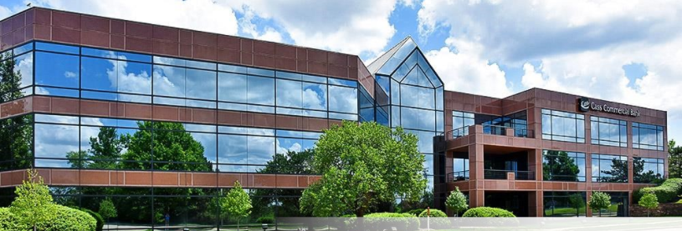

There is no cost or obligation for this meeting.
We respectfully request that you come prepared and on time.
We look forward to having the opportunity to earn your trust and confidence.

